Welcome!
Date
Name
Spouse
Address
City
State Zip _________
Email

Please Contact By
❑ Card  Phone  Visit

Telephone Best Time to Call
Home ______________
Work ______________

Guest: First Time Second Time
Are you a church member: yes no
Church
City, State

Circle Appropriate Age/Grade Group(s)
Preschool: Ages: B-1 2-3 4-5
Children: Grades: K 1 2 3 4 5 6
Youth: Grades: 7 8 9 10 11 12
Adults: Ages:18-29 30s 40s 50s 60s+

How did you learn about our church?
Newspaper Friend Yellow Pages Mail
Other

I am a guest of:

New in the Community? Yes No
Names & ages of children at home

Weekly Service & Activity Schedule

Sept 17, 2017
9:45 a.m. Sunday School
11:00 a.m. Worship Service
12:00 noon Merrell Baby Shower
6:00 p.m. “The Burden of Fear”/Business Meeting

Week of Sept 17, 2017

Wednesday 6:30 pm……………..……….Meal/Bible Study
Friday 6:30 pm……………..……………..Men’s 42 Night

Sept

10 – 17…………Week of Prayer – Mary Hill Davis Offering
24-30……………….………..Global Week of Student Prayer
26…………………..……………….Make & Take Card Class
27….See You at The Pole – National Day of Student Prayer
28……………………………………..……..Adult Fellowship

First Aid/CPR Training Classes

Weekday class – 10/19 & 10/26 @ 6:00 pm – These classes are 3 hours each and you must attend both classes to receive certification

Saturday Class – 10/21 @ 9:00 am – This is a 6 hour class for full certification

There are signup sheets on the foyer bulletin board. You must sign up if you are planning to attend. We need to know how many will be in each class.

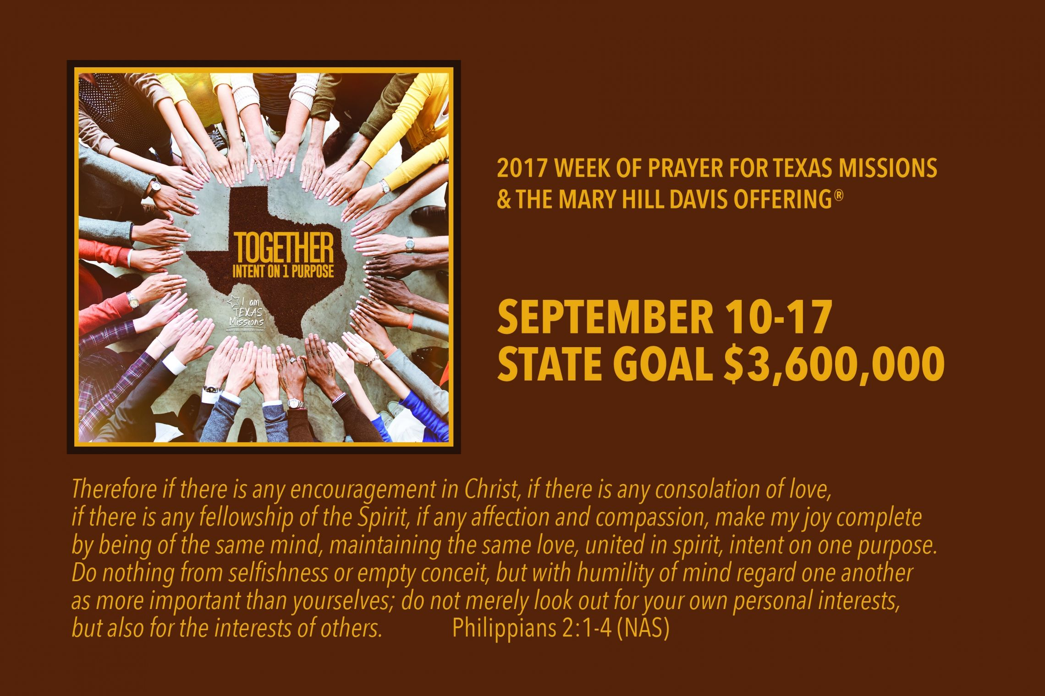

Knobbs Springs Baptist Church

Sept 17, 2017

Church Information:

KnobbsSpringsBC.com KnobbsSpringsBaptist@gmail.com

1662 CR 305, McDade, Texas 78650 512-273-2743

David Atwood, Pastor Cell 512-470-5098

Patti Radford, Office Manager Cell 512-968-7821

